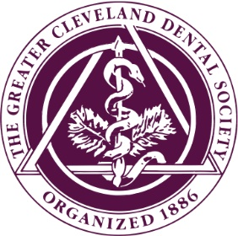
GCDS CONTINUING EDUCATION

FALL PROGRAM
OCTOBER 7, 2020 8:30AM – 12:30PM 4 CEU’S

INFECTION CONTROL FOR THE DENTAL OFFICE Fady Faddoul, DDS, MSD
This lecture will discuss the regulatory requirements for a proper infection control process in the dental office.
It will cover OSHA, State Dental Board, and other regulatory agencies requirements, including developing or updating your Office Infection Control/Exposure Control manual.
At the conclusion of the lecture, the participant will be able to:
- Understand the rational for infection control
- Develop and/or update their infection control Manual based on the latest rules and regulations
- Understand OSHA and State Board Regulations
- Understand other mandate infection control regulations
- Develop an office training program
- Understand office inspection protocols
- Ask questions related to office infection control protocols
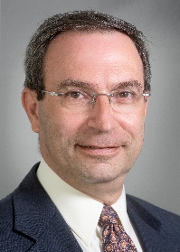
Fady Faddoul, DDS, MSD, is a 1988 and 1992 graduate of CWRU School of Dental Medicine. Dr. Faddoul is a professor and Chairman of the Department of Comprehensive care at CWRU School of Dental Medicine, the infection control and safety officer, as well as the director the School of Dental Medicine’s Faculty Practice. He is a member of the American Dental Association, the Ohio Dental association, The Greater Cleveland Dental Society, the American Dental Education Association, and a Fellow in both the International College of Dentists and the American College of Dentists.

Dr. Faddoul served as the 126th President of the Greater Cleveland Dental Society from 2012-2013 and has served on multiple GCDS, ODA, and ADA committees, and/or councils including as the GCDS Service Corporation Board Chair, an ODA House of Delegates Alternate Delegate, and as an ADA Alternate Delegate. Additionally, he has been a consultant member of the ADA Commission on Dental Accreditation as well as the Commission on Dental Competency Assessment, the ODA Dental Education and Licensure Committee and the GCDS/Case Joint Committee on Continuing Education.

Currently, he is a delegate to the ODA House of Delegates, and serves on the ODA Finance Committee, the GCDS Finance Committee, the North Coast Planning Committee and the GCDS Foundation Board.

NOVEMBER 4, 2020 8:30AM – 12:30PM 4 CEU’S

ORAFACIAL PAIN & DENTAL SLEEP MEDICINE:
A PRIMER FOR DENTAL MEDICINE Andres Pinto, DMD
This course will discuss the overlapping occurrence of orofacial pain and sleep disorders. The patient with pre-existent facial pain presents a treatment challenge to the sleep clinician. Also, the management of sleep disordered breathing with mandibular advancement devices (MAD) may cause facial pain symptoms.
At the conclusion of the lecture, the participant will:
- Recognize the association of facial pain and sleep
- Assess the patient with facial pain who may present with sleep related complaints
- Learn approaches to patients with sleep disordered breathing who are intolerant to C-PAP, and who develop facial pain on MAD treatment
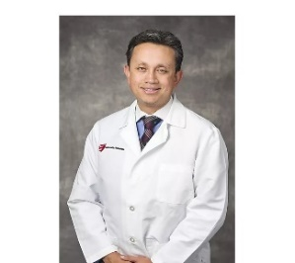

Andres Pinto DMD, MPH, MSCE, MBA, is a Professor with tenure and Chairman, Department of Oral and Maxillofacial Medicine and Diagnostic Sciences, and Assistant Dean for Graduate Studies at Case Western Reserve University, School of Dental Medicine. Also, he is a Professor of Medicine, and a consultant in Orofacial Pain and Oral Medicine at the Cleveland VA Medical Center. Dr. Pinto received his Doctor of Medicine in Dentistry from the University of Pennsylvania, and residency training in the Division of Oral and Maxillofacial Surgery at Penn Health System (Oral Medicine). He also received advanced training in Orofacial Pain and Dental Sleep Medicine at the University of Kentucky and Tufts University in Boston, and residency training in Dental Public Health at the National Institutes of Health in Bethesda, Maryland. He completed several graduate degrees, including an MPH, an MS in Clinical Epidemiology, at the University of Pennsylvania Perelman School of Medicine, and an MBA in Health Care Administration at the Weatherhead School of Management and the Cleveland Clinic. Dr. Pinto has twenty-one years of experience in the clinical management of orofacial pain disorders.
He is a Diplomate of the American Board of Oral Medicine and the European Association of Oral Medicine and holds a Fellowship in the Royal College of Surgeons of Edinburgh (United Kingdom) and the International College of Dentists. Dr. Pinto is the current President-Elect of the American Academy of Oral Medicine and an active contributor to the scientific literature, with more than 70 published papers, abstracts, and editorials. He is the co-editor of a book on clinical risk assessment in Dental Medicine and delivered more than 80 presentations and CE courses in the United States and abroad.

NOVEMBER 18, 2020 8:30AM – 12:30PM 4 CEU’S

OCCLUSAL CONCEPTS in RESTORATIVE DENTISTRY Jay Resnick, DDS
Occlusion affects every aspect of restorative and prosthetic treatment. It is the number one cause of restorative failure; yet, it remains the most undiagnosed problem. Having a sound understanding of occlusion will not only improve treatment outcomes, but offer clinicians an additional treatment area. The goals for the presentation are:
• Promote an understanding of how occlusion influences our restorative results
• Enable participants an opportunity to include an occlusal exam in their patient evaluation
• Encourage participants to recognize and treat occlusal disorders.
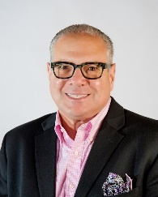
Jay Resnick DDS, is a 1972 graduate of The Ohio State University College of Dentistry. Following his GPR at the Mt. Sinai Hospital, he joined Dr. Richard Streem and the late Dr. Rubin Pyner in their dental practice. After 47 years, he retired in 2019, beginning a new second career as a member of the restorative faculty of the CWRU, School of Dental Medicine, where he serves as an Associate Professor.
He is an active member of OKU, the International Academy of Adhesive Dentistry, the L D Pankey Alumni Association, and is a board member of the Academy of Biomimetic Dentistry. He will be the chairman of the 2022 ODA Annual Session as Dr. Tom Kelly is installed as president.

2020 FEES PER COURSE

ADA Members: $100 New Dentists: (in practice under 10 yrs.): $75 Dental Staff: $65 Non-ADA Members: $150

All courses will be held at GCDS Headquarters: 4807 Rockside Road (Conference Room Lower level)

(A continental breakfast will be served beginning at 8:00am)

HOW TO REGISTER:
- On-Line at www.gcds.org
- Mail your registration with payment by check or credit card to:
4807 Rockside Road Suite 270, Independence, OH 44131
- Email to peg@gcds.org
• Fax 440-717-1894

Courses: Check Course (s) you will be attending:

October 7th _______ November 4th ________ November 18th ________

Attendee Name: Email: _____________________________________

Address: City: Zip:

Phone #:

CC #: Exp. Date: CV #:

Zip Associated with Card:

GENERAL INFORMATION:
- See each course description for time and CE Credits
- Seating is limited FOR SOCIAL DISTANCING
- MASKS WILL BE REQUIRED
- Business Casual Attire
- A continental breakfast will be served
- CE Certificates will be issued the day of the course
- Cancellations less than 7 days prior to an event are subject to a $35.00 fee. No cancellations less than 2 business days before the event.
- We reserve the right to cancel or change the location of any course at least 15 days in advance
- All attendees grant permission to GCDS for the future use of any publicity photos taken during any or all of the courses.

This activity has been planned and implemented in accordance with the standards of the Academy of General Dentistry Program Approval for Continuing Education (PACE) through The Greater Cleveland Dental Society (GCDS).
The GCDS is approved for awarding FAGD/MAGD credit. Approval does not imply acceptance by a state or provincial board of dentistry or AGD endorsement 1/1/2017 to 12/31/2020.

